Vincent Hu

EENG 348a

October 2, 2013

Project 5

**Project Description**

In this project, we will implement a transient recorder that acquires 35 samples of waveform using a sampling period specified on the serial monitor. The recorder will then display the acquired waveform samples on the serial monitor with 6-bit resolution.

**Flow Chart**

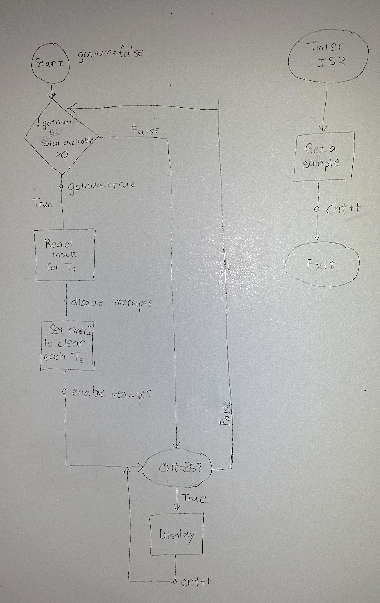

**Programs**

Please refer to code in current directory.

**Description of operation**

We acquire the sample period value T_s from the user by setting a one-time boolean variable called gotnum, which signifies whether or not we have received T_s yet. In this conditional, we read each byte into a char array and then convert it into an integer. In this section, we also set the timer to clear timer on compare and the compare value to the period * 16 * 1000 in order to get the value on which the counter clears. The recorder operates at an minimum achievable ADC conversion time by setting the timer prescaler to off, and setting the ADC prescaler to its smallest value, 2. This allows the ISR and the ACD processes to complete at the minimum time because both clock speeds are at their highest. The recorder triggers data acquisition when ADC signal exceeds threshold, and we use a counter to keep track of how many interrupts have been called, and when the counter reaches 35, interrupts are turned off. To print out the results, the program keeps track of the maximum as we print samples, and then prints out the max at the end of the diagram. After printing the results, we increment cnt by 1 to ensure that the program goes into an infinite loop.

**Monitor Display with T_s = 50**

T_s (ms)= 50

0 *

1 | *

2 | *

3 | *

4 | *

5 | *

6 | *

7 | *

8 | *

9 | *

10 | *

11 | *

12 *

13 *

14 *

15 *

16 *

17 | *

18 | *

19 | *

20 | *

21 | *

22 | *

23 | *

24 | *

25 | *

26 | *

27 *

28 *

29 *

30 *

31 *

32 *

33 *

34 *

Max val= 63

**Circuit Diagram**

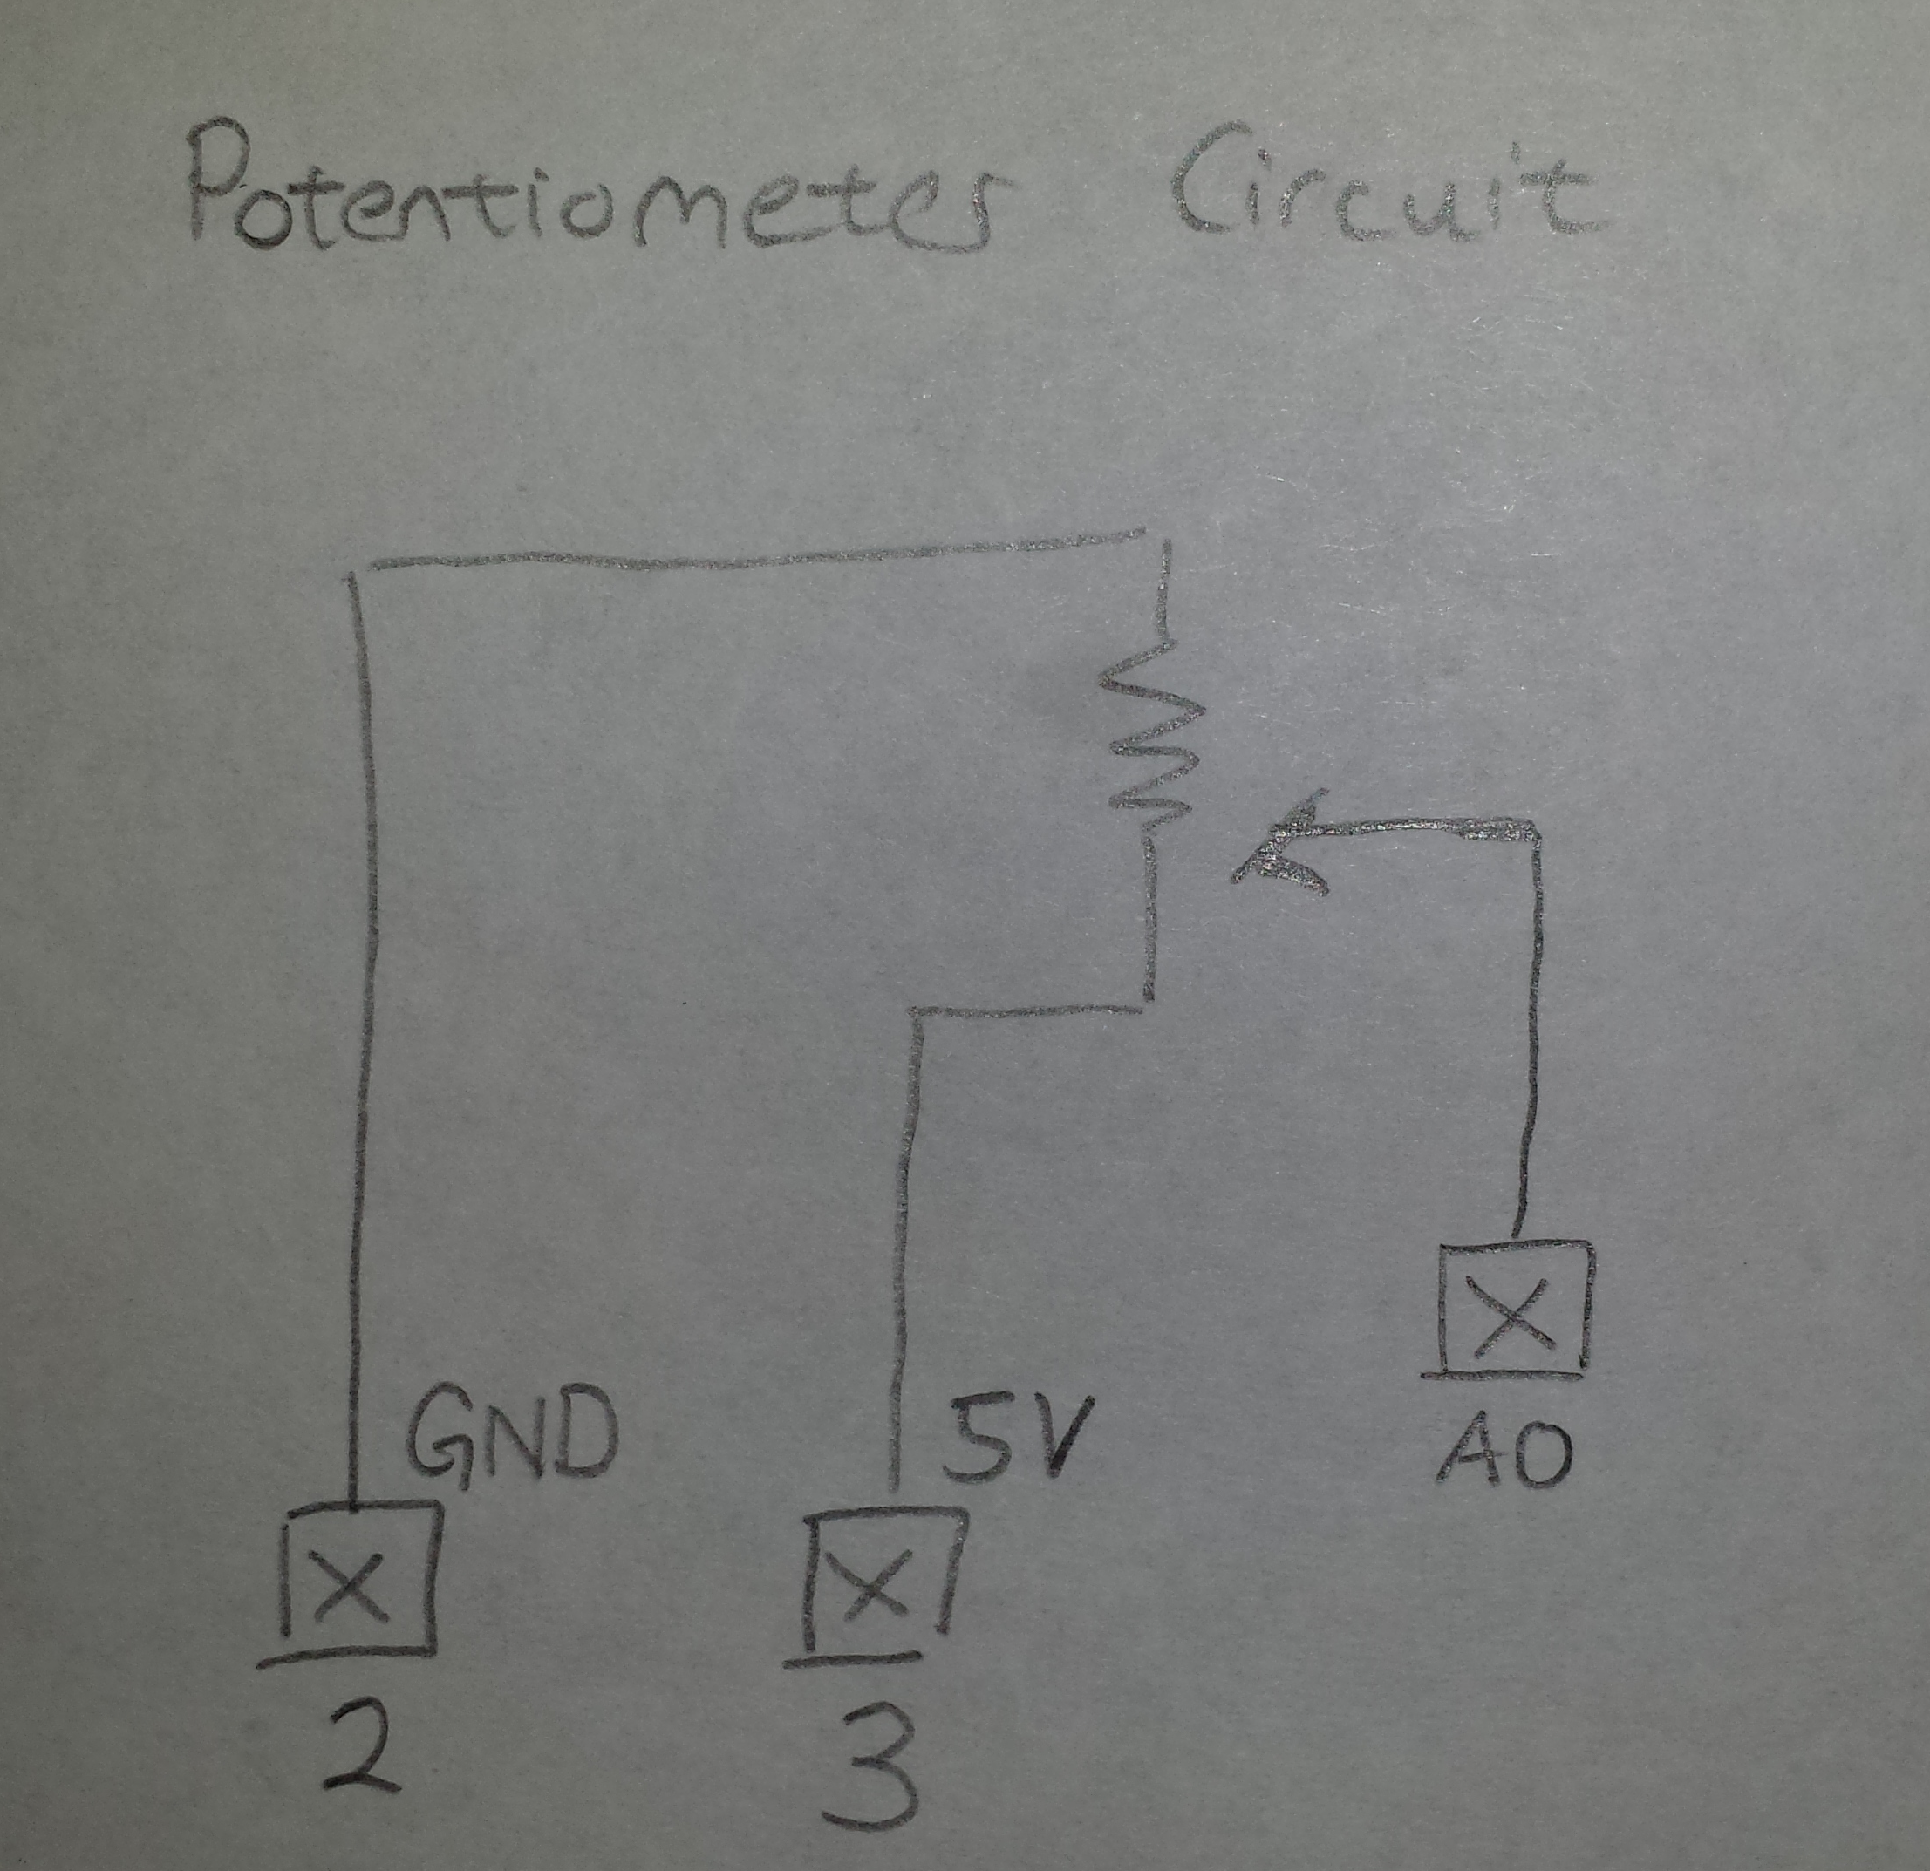

**Notes**

To better understand how the ADC prescaler would affect sampling speed, we created the following table which shows that decreasing the ADC prescaler value increases the cycles per sample:

|  |  |  |
| --- | --- | --- |
| ADC Prescaler Value | Time (ns) | Cycles per sample  (T_s = 1ms) |
| 2 | 125 | 8000 |
| 4 | 250 | 4000 |
| 8 | 500 | 2000 |
| 16 | 1000 | 1000 |
| 32 | 2000 | 500 |
| 64 | 4000 | 250 |
| 128 | 8000 | 125 |